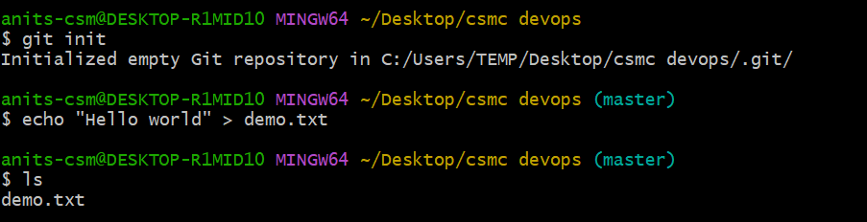

- Initialize git
- Create a text file in your folder
- Stage the “demo.txt” file
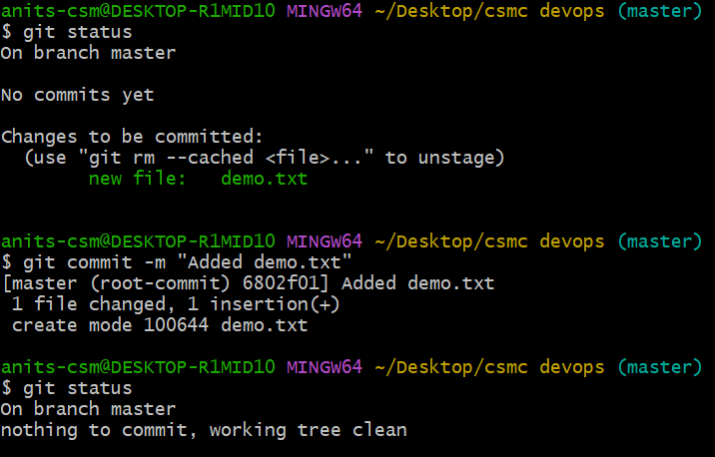
- Committing the changes and checking the status
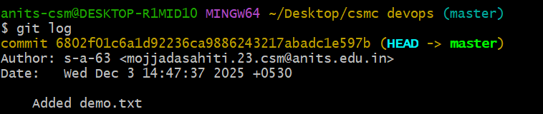
- Checking the history
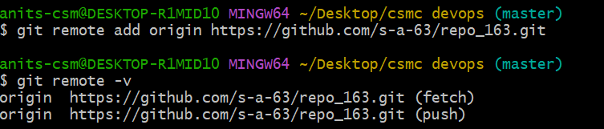
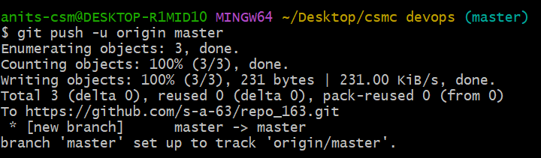
- Pushing the file to remote repository

